17. Reconstruction or Simulation of Data
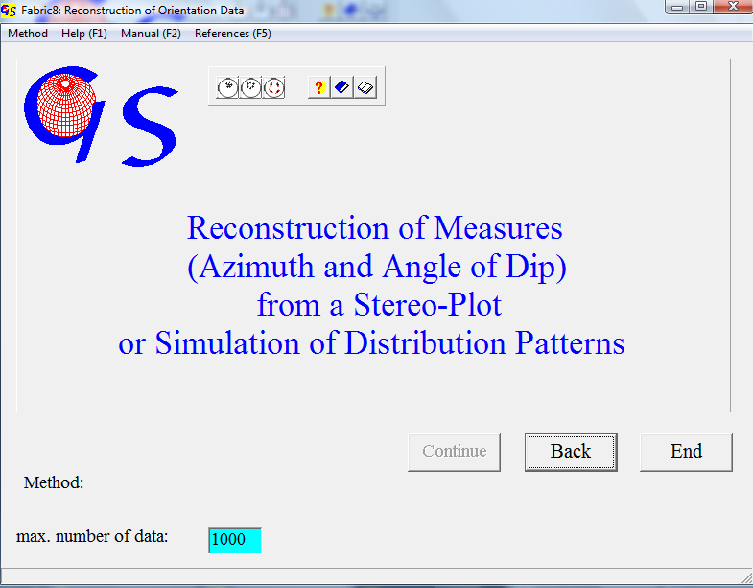
Fig. 1

This Program (Fig. 1) enables you to produce a list of data by clicking on points in a bitmap of a strereonet. In the menu “Method” you can choose between three different ways of data acquisition.

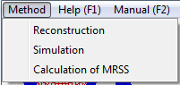
Fig. 2

Reconstruction
Click on "Reconstruction" when you want to reconstruct the data of points in an already existng stereonet. After clicking on this option the form "Calculation of azimuth and dip angle from the data points" appears. After pressing the button “Start” it looks like Fig. 3.
Import of the diagram is the same as in programme 4 or 5.
In the menu “Projection you now choose the projection in which the diagram was drawn, an in the menu “Type of fabric” you click either on ‘Linears’ or ‘planes’
Now you are asked to click on the ends of the E-W diameter of the diagram (Fig. 4). Next you have to click on the button "Cut out" (Fig. 5).
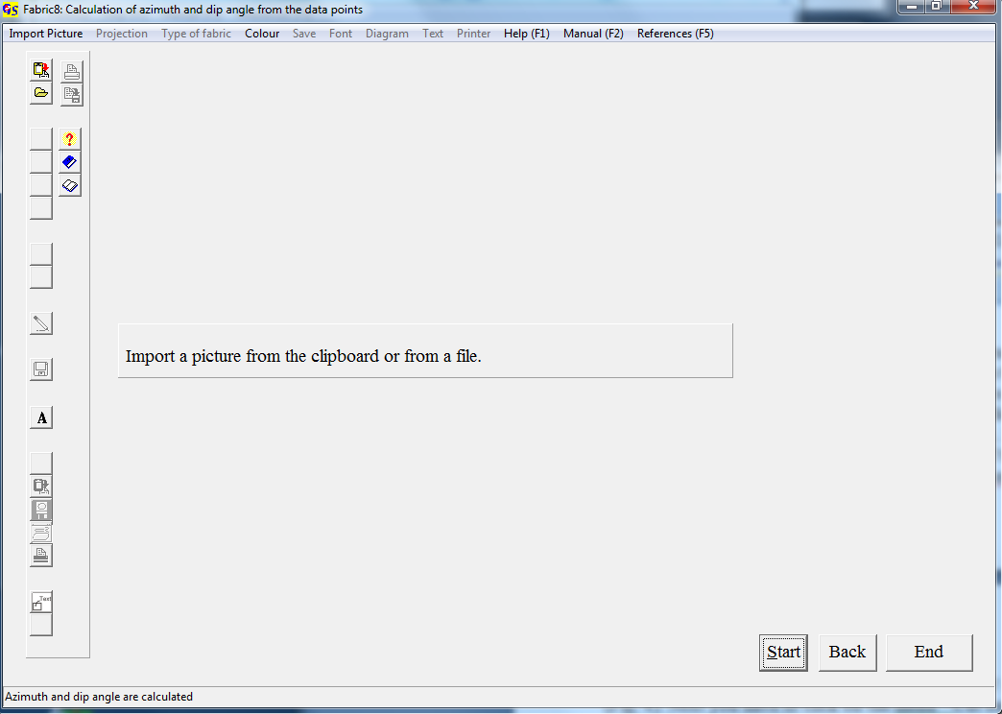
Fig. 2

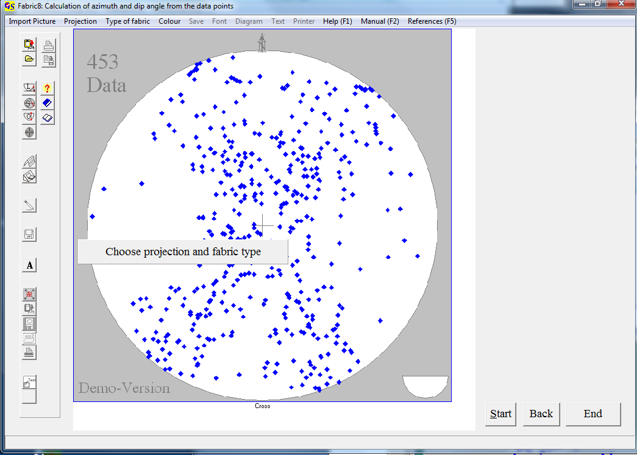
Fig. 3

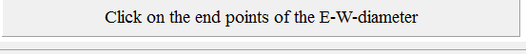
Fig. 4
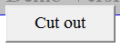
Fig. 5

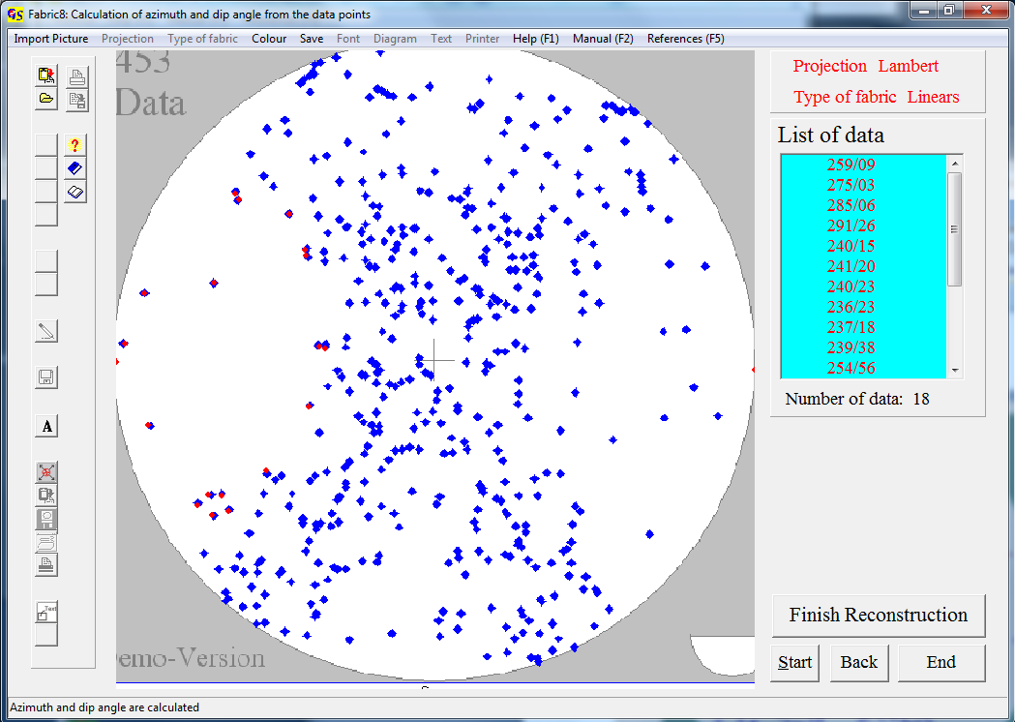
Fig. 6

The diagram is stretched to fill the whole screen. Now you can click on the points with the left mouse button (Fig. 6). The colour of the clicked points can be chosen from the menu "Colour". The data of the clicked points appear in the list on the right side. Press "Finish reconstruction” when all pointa are clicked. Data can now be saved and/or printed.
The options of the menu "Diagram" are described in program 3.

Simulation
With this option you can create data of certain patterns (Great circles, small circles) for didactic or other purpose. Pressing "Simulation" in the start form produces an empty diagram with the demand "Choose projection and fabric type" (Fig. 7).
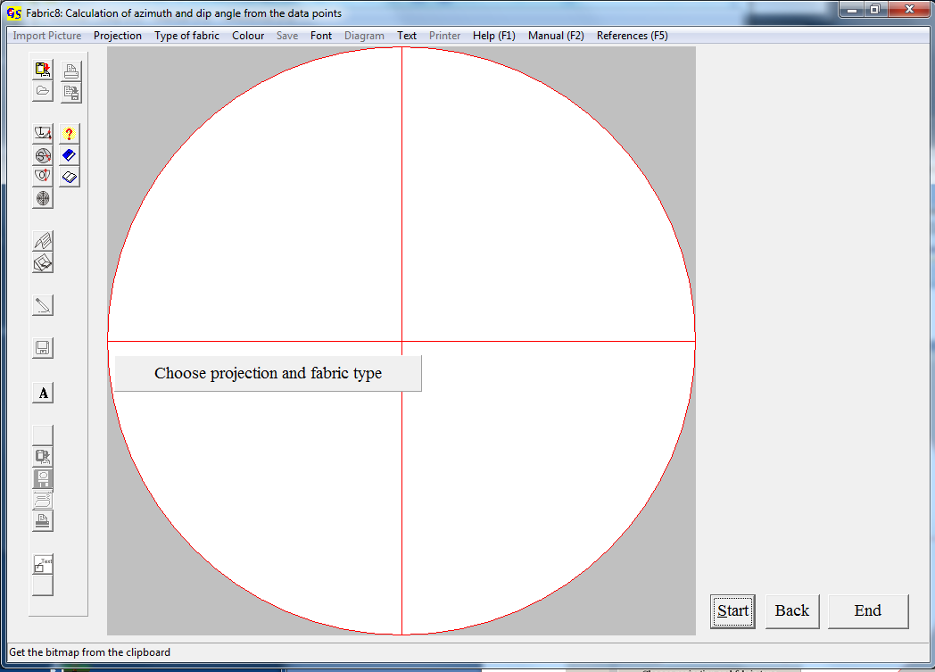
Fig. 7

By Clicking into this diagram with the left mouse button, you can create special distribution patterns (Fig. 8). After pressing "Finish simulation" you can save and/or print the data of thes patterns.

Calculation of MRSS
The option "Calculation of MRSS" (Fig. 2) calculates the theoretical directions of striations on simulated slickenside planes as 'maximum resolved shear stresses (MRSS)'. Clicking the button "Calculation of MRSS" produces an empty diagram with the demand "Choose projection" (Fig. 9). To proceed input of the shape factor and the directions of σ₁ and σ₃ of the assumed stress ellipsoid is necessary (Fig. 10). After this input you can produce simulated slickenside planes by clicking in the empty diagram (Fig. 11). The procuced striation appear in the list to the right of the diagram.
When you press "Finish simulation", a list with the data of the simulated slickenside and the calculated striations appears (Fig. 12). These data can now be saved and/or printed.

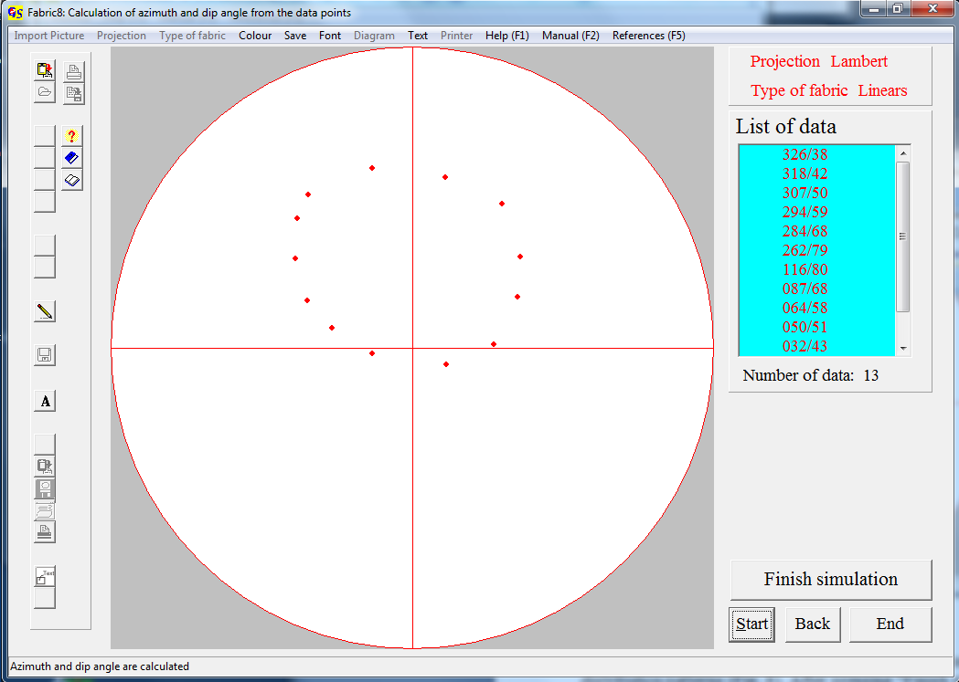
Fig. 8

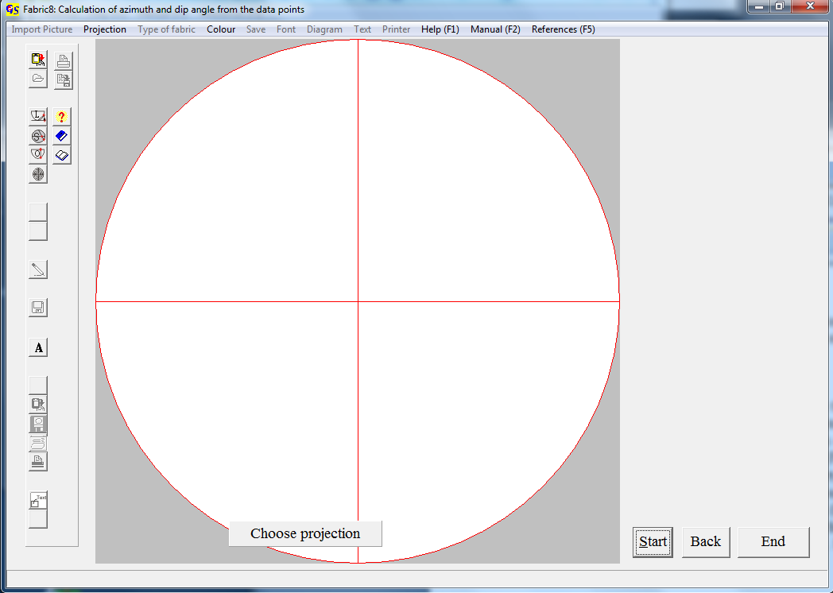
Fig. 9

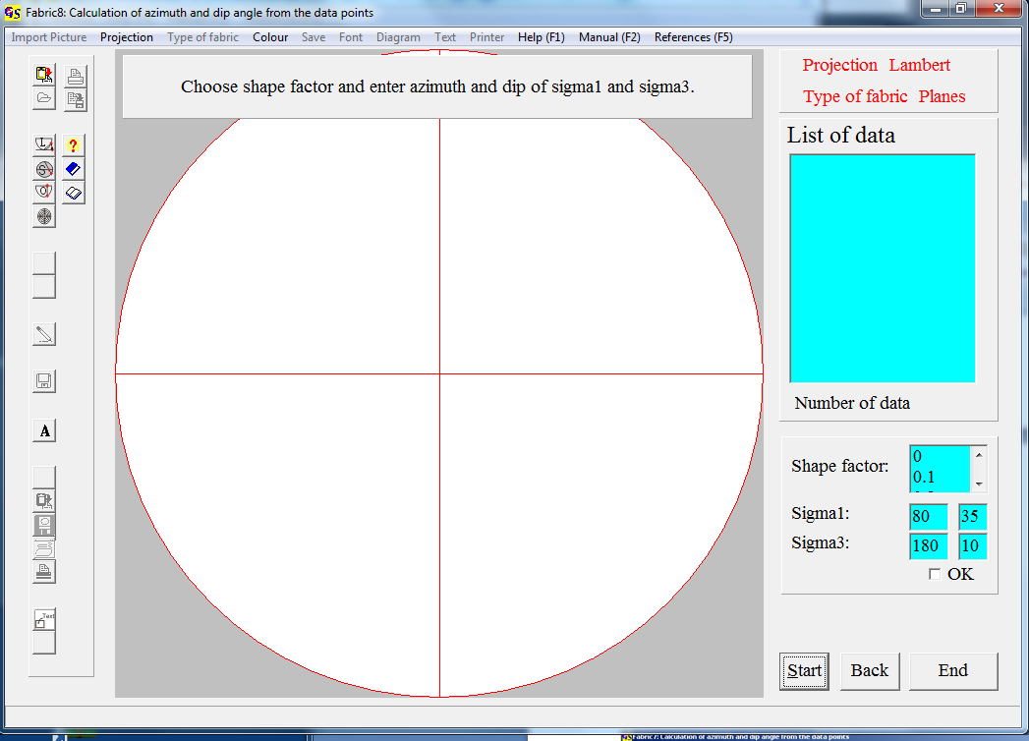
Fig. 10

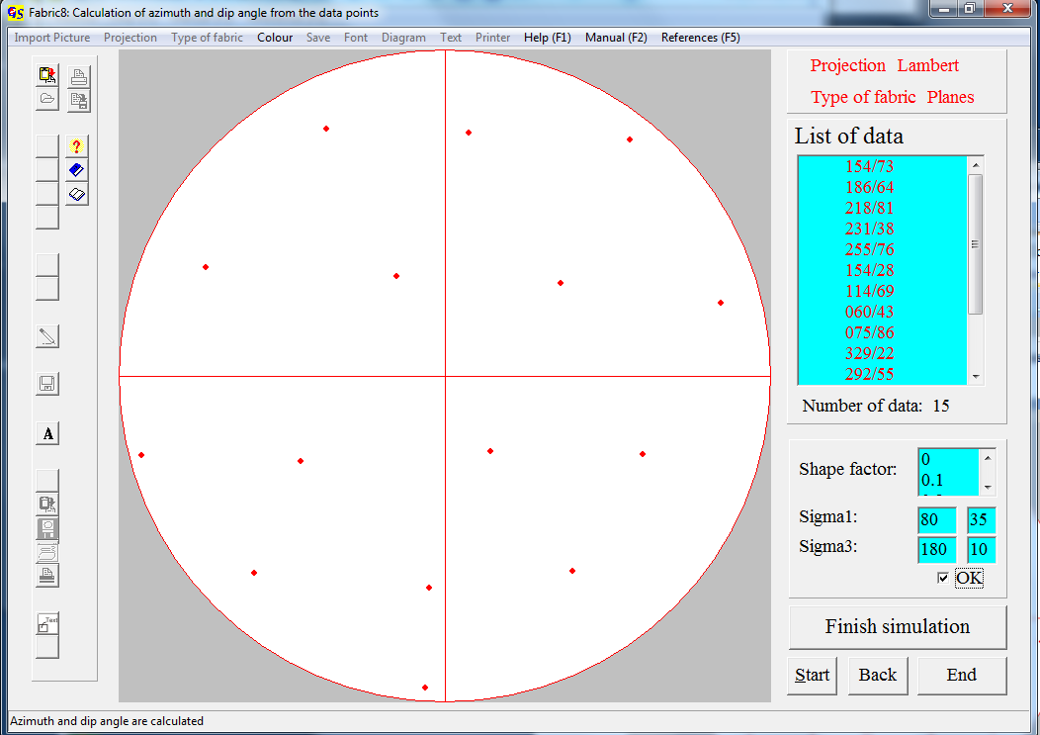
Fig. 11
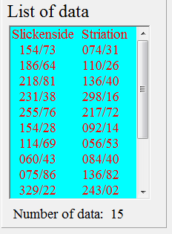
Fig. 12

